ENVIROTIME: DIGITAL CLOCK
WITH REAL-TIME TEMPERATURE
MONITORING

Submitted by
Gayathri Kolli
V25HE8K7

Acknowledgement
I would like to express my sincere gratitude to our department faculty, guide, and institution for providing me the opportunity to carry out this mini project titled “EnviroTime: Digital Clock with Real-Time Temperature Monitoring.” Their guidance, encouragement, and technical support helped me complete this project successfully.
Table of contents
S.No | Title
1 | Introduction
2 | Aim
3 | Objectives
4 | Block Diagram
5 | Hardware Requirements
6 | Software Requirements
7 | Component Description
8 | Circuit Diagram
9 | Flowchart
10 | Program Explanation & Source Code
11 | Results and Output
12 | Applications
13 | Advantages
14 | Conclusion
15 | Future Scope
16 | References

- Introduction:
Embedded systems play an important role in automation and real-time monitoring applications. This project EnviroTime, is designed using the NXP LPC2148 microcontroller to display accurate time and continuously monitor ambient temperature. The system combines Real-Time Clock functionality, temperature sensing, password-based security, alarm indication, and user interaction through keypad and switches. The measured information is displayed on a 16×2 LCD, making the system suitable for homes, offices, laboratories, and industrial applications.
- Aim:
To design and develop a real-time embedded system using the LPC2148 microcontroller that displays accurate digital clock information along with continuous ambient temperature monitoring, while allowing secure user-controlled modification of time and alarm settings through switch-based polling and keypad authentication.
- Objectives:
- Implement Real-Time Clock (RTC) for accurate display of time, date, day, month, and year. Monitor ambient temperature using LM35 sensor through on-chip ADC
- Display real-time clock and temperature information on a 16×2 LCD
- Provide alarm setting functionality for user-defined time alert
- Interface keypad for secure password-based user input and parameter modification
- Use switch-based polling to enter edit mode for updating RTC and alarm settings
- Generate buzzer alerts for alarm indication and system notifications
- Block Diagram:
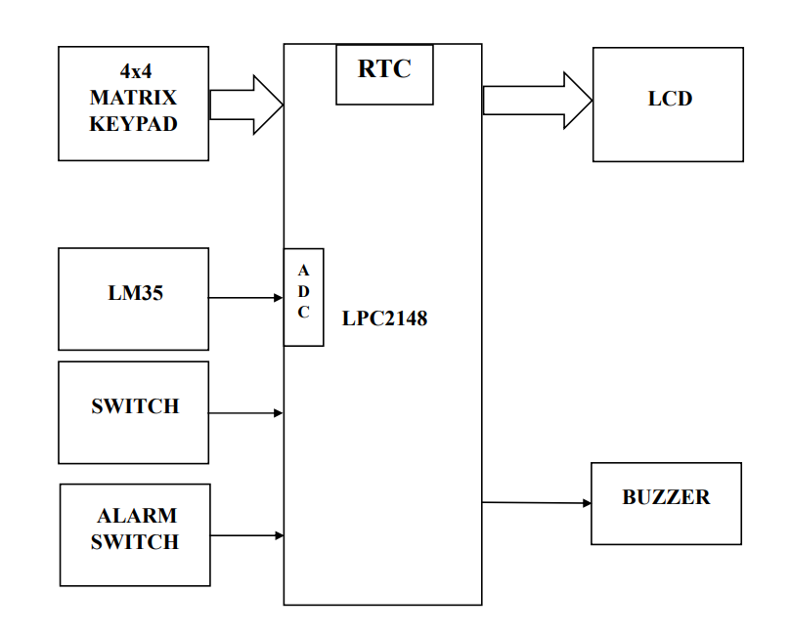
Note: In real hardware, we used buzzer but on Proteus simulation for visibility of output we used LED for alarm indication
- HARDWARE REQUIREMENTS:
- LPC2148
- 16X2 LCD
- 4X4 MATRIX KEYPAD
- SWITCH
- LM35
- BUZZER
- USB-UART CONVERTER / DB-9 CABLE
- SOFTWARE REQUIREMENTS:
- EMBEDDED-C PROGRAMMING
- FLASH MAGIC
- Component description:
  - LPC2148 :
The LPC2148 is a 32-bit ARM7 based microcontroller developed by NXP Semiconductors. It is the main controller used in this project. It controls all peripheral devices such as LCD, keypad, switches, buzzer, and temperature sensor. It contains built-in features like ADC, RTC, UART, GPIO, timers, and interrupt support, making it suitable for real-time embedded applications.
Important features:
- 32-bit ARM7TDMI-S core
- Operating frequency up to 60 MHz
- Built-in ADC
- Built-in RTC
- UART communication support
- Multiple GPIO pins
- 32 KB RAM, 512 KB Flash memory
  - 16×2 LCD Display:
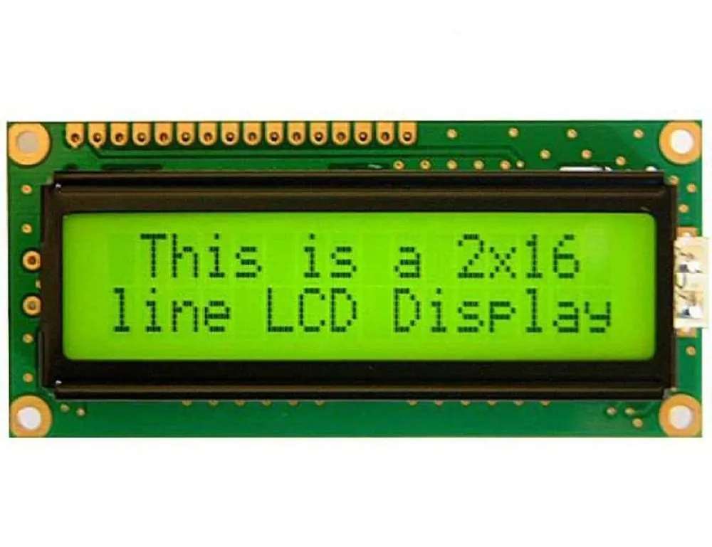
A 16×2 LCD display is used to display system information. It can display 16 characters in 2 rows.
In this project, it displays:
- Current time
- Date and day
- Temperature
- Alarm messages
- Password prompts
The LCD provides a user-friendly interface.
  - 4×4 Matrix Keypad :
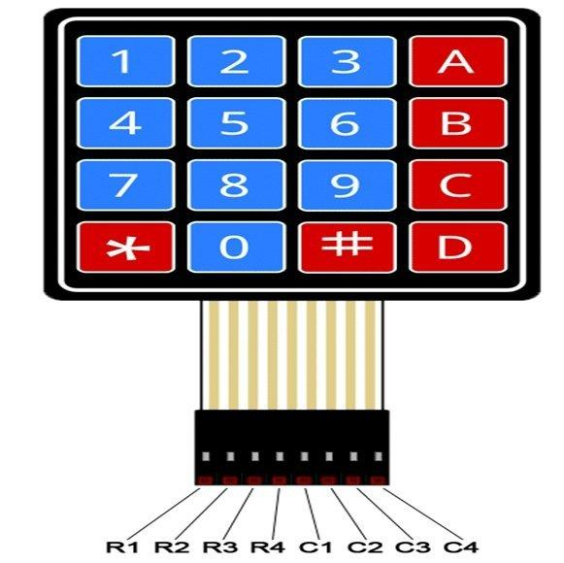
The keypad is used to enter numerical values and passwords. It consists of 16 keys arranged in 4 rows and 4 columns.
Functions:
- Password entry
- Time modification
- Alarm setting
- Password change
  - Switch :
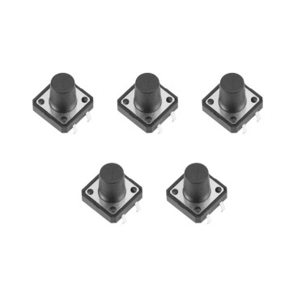
Switches are used for manual control.
Functions:
- Enter edit mode
- Stop alarm
The switches are monitored using polling.
  - LM35 :
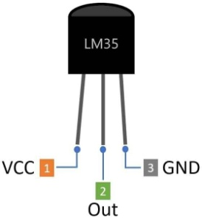
LM35 is an analog temperature sensor used to measure ambient temperature. It produces an output voltage proportional to temperature in degree Celsius.
Features:
- Calibrated in Celsius
- Low power consumption
- High accuracy
- Easy ADC interfacing
  - Buzzer:
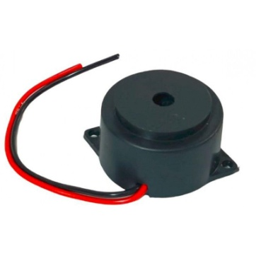
The buzzer generates sound alerts.
Functions:
- Alarm indication
- Security alerts
- Wrong password indication
  - USB-UART Converter / DB-9 Cable:
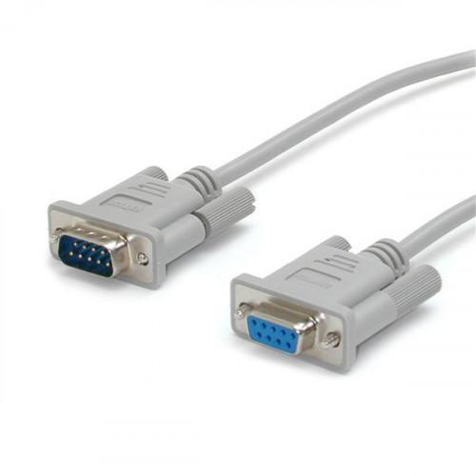
This module is used for serial communication between the computer and the LPC2148 board.
Functions:
- Program downloading
- Serial communication
- Debugging
- Flash programming
- Circuit Connections

  - LPC2148 to 16×2 LCD :

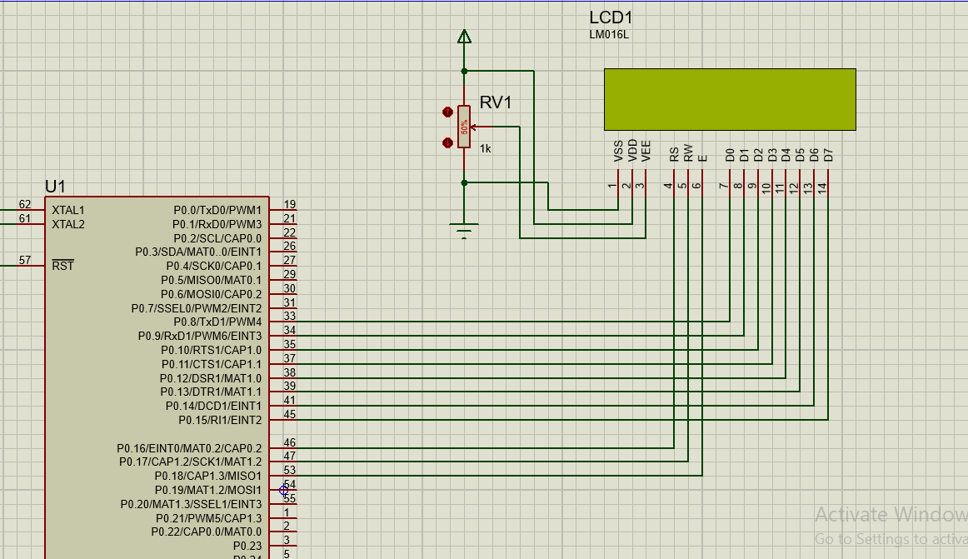
The LCD is interfaced with GPIO pins of the microcontroller in 8-bit mode.
LCD Pin | Signal | Connected To
Pin 1 | VSS | GND
Pin 2 | VDD | +5V
Pin 3 | VEE | Potentiometer (RV1) output
Pin 4 | RS | P0.16
Pin 5 | RW | P0.17
Pin 6 | EN | P0.8
Pin 7 | D0 | P0.9
Pin 8 | D1 | P0.10
Pin 9 | D2 | P0.11
Pin 10 | D3 | P0.12
Pin 11 | D4 | P0.13
Pin 12 | D5 | P0.14
Pin 13 | D6 | P0.15
Pin 14 | D7 | P0.18

  - LPC2148 to LM35:
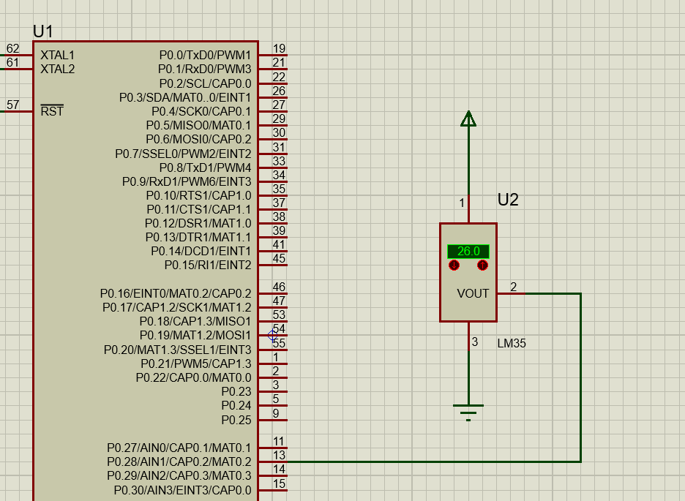
LM35 output is connected to ADC input of the microcontroller.

LM35 Pin | Signal | Connected To
Pin 1 | VCC | +5V
Pin 2 | Output | P0.28 (AD0.1)
Pin 3 | GND | Ground
The analog signal is converted into digital temperature values.
  - Keypad Interfacing with LPC2148:

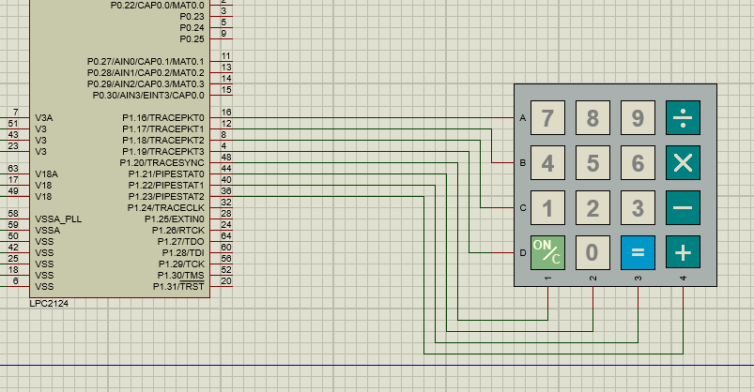

The 4×4 matrix keypad is used for secure user input such as password entry, time modification, alarm setting, and password change. The keypad consists of 4 rows and 4 columns.

Keypad Pin | Signal | Connected To
Pin 1 | Row A | P1.16
Pin 2 | Row B | P1.17
Pin 3 | Row C | P1.18
Pin 4 | Row D | P1.19
Pin 5 | Column 1 | P1.20
Pin 6 | Column 2 | P1.21
Pin 7 | Column 3 | P1.22
Pin 8 | Column 4 | P1.23

  - Buzzer Interfacing with LPC2148:
The buzzer is connected to one GPIO output pin.
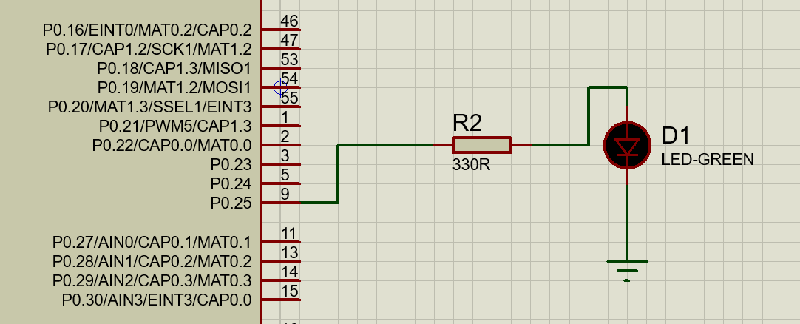
An Active High LED is used instead of a buzzer in Proteus for better visual indication of alarm and security notifications during simulation.
In real hardware buzzer is used.
Component | Signal | Connected To
LED Anode | Positive terminal | P0.25 through 330Ω resistor
LED Cathode | Negative terminal | Ground

  - Switch Interfacing with LPC 2148 :
Switches are active low.
    - Edit Switch
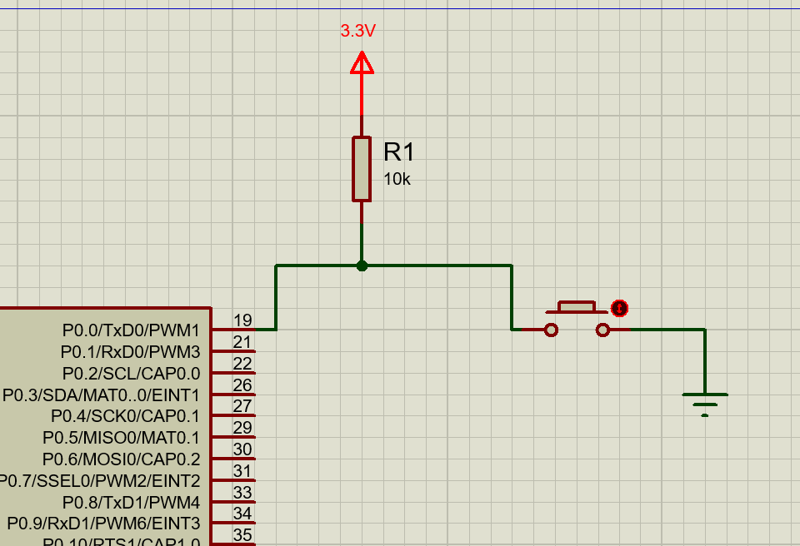
Component | Signal | Connected To
Switch Terminal 1 | Input | P0.0
Switch Terminal 2 | Ground | GND
Pull-up Resistor | 10kΩ | +3.3V

The edit switch is used to enter secure edit mode. When this switch is pressed, the microcontroller prompts the user to enter the password through the keypad. After successful authentication, the user can modify time, date, alarm settings, and password.

    - Alarm Stop Switch

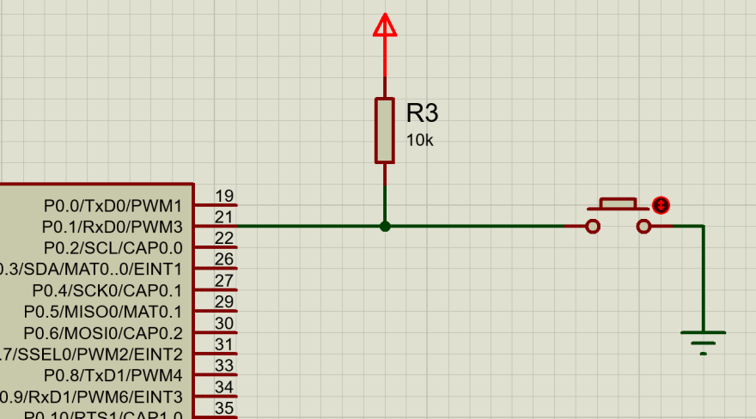
Component | Signal | Connected To
Switch Terminal 1 | Input | P0.1
Switch Terminal 2 | Ground | GND
Pull-up Resistor | 10kΩ | +3.3V

The alarm stop switch is used to stop the alarm indication. When the alarm time matches the current RTC time, the LED glows. Pressing this switch turns OFF the LED and returns the system to normal monitoring mode.

  - Full Circuit connections :
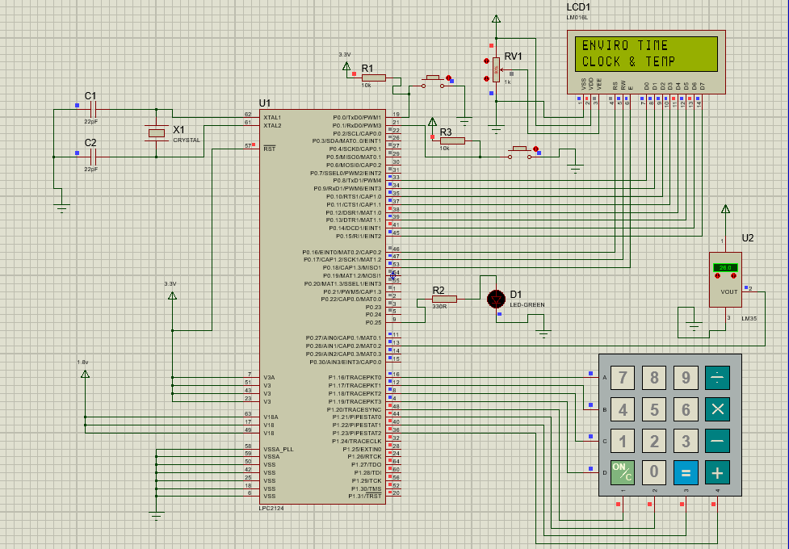

- Flow chart :
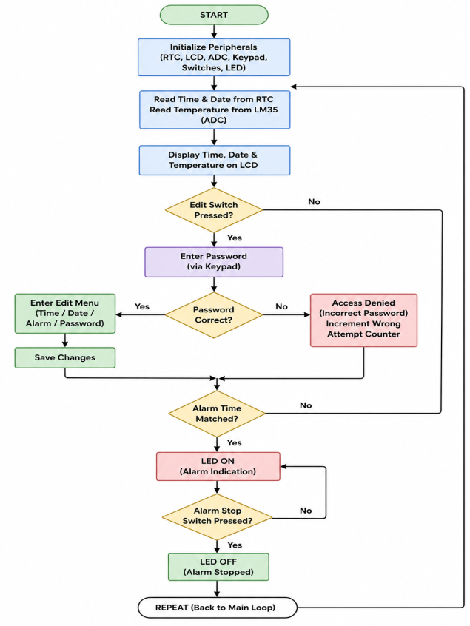
- Program Explanation / Source Code:
  - Program Explanation :
- The program is written in Embedded C for the LPC2148 microcontroller. It initializes all required peripherals such as LCD, RTC, ADC, keypad, switches, and LED. After initialization, the controller continuously reads the real-time clock values and temperature sensor value, then displays them on the 16×2 LCD.
- The edit switch is checked using polling. When the edit switch is pressed, the system asks the user to enter a password through the 4×4 keypad. If the password is correct, the edit menu is displayed, where the user can modify time, date, alarm time, or password. If the password is incorrect, access is denied.
- The alarm time is continuously compared with the current RTC time. When both match, the LED turns ON as an alarm indication. The LED remains ON until the alarm stop switch is pressed.
  - Source Code :
    - Main.c
#include <lpc21xx.h>
#include "type.h"
#include "kpm.h"
#include "lcd.h"
#include "rtc.h"
#include "lcd_defines.h"
#include "kpm_defines.h"
#include "Intial.h"
#include "delay.h"
#include "adc.h"
#include "lm35.h"
#define BUZZER_PIN 25
#define EDIT_SW 0
#define ALARM_STOP_SW 1
extern s8 default_password[5];
u32 h = 12;
u32 mi = 30;
u32 s = 0;
u32 d = 3;
u32 mo = 5;
u32 y = 2026;
u32 da = 1;
u32 alarm_hour = 12;
u32 alarm_min = 31;

u32 wrong_count = 0;
u32 alarm_flag = 0;
int main()
{
Init_system();
//P0.25 as GPIO output for buzzer/LED
PINSEL1 &= ~(3 << 18);
IODIR0 |= (1 << BUZZER_PIN);
CmdLCD(CLEAR_LCD);
StrLCD("ENVIRO TIME");
CmdLCD(GOTO_LINE2_POS0);
StrLCD("CLOCK & TEMP");
delay_ms(1500);
CmdLCD(CLEAR_LCD);
while(1)
{
display_envirotime();
check_alarm();
//EDIT SWITCH
if(((IOPIN0 >> EDIT_SW) & 1) == 0)
{
delay_ms(50);
if(((IOPIN0 >> EDIT_SW) & 1) == 0)
{
while(((IOPIN0 >> EDIT_SW) & 1) == 0);
if(wrong_count >= 3)
{
u32 sec_count, beep;
//buzzer beeps 3 times
for(beep = 0; beep < 3; beep++)
{
IOSET0 = 1 << BUZZER_PIN;
delay_ms(200);
IOCLR0 = 1 << BUZZER_PIN;
delay_ms(200);
}
CmdLCD(CLEAR_LCD);
delay_ms(5);
CmdLCD(GOTO_LINE1_POS0);
StrLCD("SYSTEM LOCKED");

for(sec_count = 45; sec_count > 0; sec_count--)
{
CmdLCD(GOTO_LINE2_POS0);
StrLCD("WAIT: ");
CharLCD((sec_count / 10) + '0');
CharLCD((sec_count % 10) + '0');
StrLCD(" SEC ");
delay_ms(1000);
}
wrong_count = 0;
CmdLCD(CLEAR_LCD);
delay_ms(5);
continue;
}
if(password())
{
wrong_count = 0;
process_edit_menu();
}
else
{
wrong_count++;
CmdLCD(CLEAR_LCD);
StrLCD("ACCESS DENIED");
delay_ms(500);
IOSET0 = 1 << BUZZER_PIN;
delay_ms(1000);
IOCLR0 = 1 << BUZZER_PIN;
CmdLCD(CLEAR_LCD);
delay_ms(5);
}
}
}
//ALARM STOP SWITCH
if(alarm_flag == 1 &&
(((IOPIN0 >> ALARM_STOP_SW) & 1) == 0))
{
IOCLR0 = 1 << BUZZER_PIN;
alarm_flag = 0;
while(((IOPIN0 >> ALARM_STOP_SW) & 1) == 0);
}
delay_ms(200);
}
}
    - Adc.c
#include <lpc21xx.h>
#include “adc.h”
void Init_ADC(void)
{
PINSEL1|=1<<24;
ADCR=(1<<1)|
(4<<8)|
(1<<21);
}
u32 Read_ADC(void)
{
ADCR|=1<<24;
while(((ADDR>>31)&1)==0);
return (ADDR>>6)&1023;
}
    - Alarm.c
#include "Intial.h"
#include <lpc21xx.h>
#include "lcd.h"
#include "rtc.h"
#include "lcd_defines.h"
#include "delay.h"
#include "type.h"
#define BUZZER_PIN 25
extern u32 alarm_hour, alarm_min;
extern u32 alarm_flag;
void alarm_time_setting(void)
{
CmdLCD(CLEAR_LCD);
StrLCD("ALARM HOUR");
alarm_hour = get_hour_from_user();
CmdLCD(CLEAR_LCD);
StrLCD("ALARM MIN");
alarm_min = get_min_from_user();
CmdLCD(CLEAR_LCD);
StrLCD("ALARM SAVED");
delay_ms(1000);
CmdLCD(CLEAR_LCD);
}
void check_alarm(void)
{
s32 h, m, s;
static u32 alarm_done = 0;
GetRTCTimeInfo(&h, &m, &s);
//trigger only once
if((h == alarm_hour) &&
(m == alarm_min) &&
(alarm_done == 0))
{
alarm_flag = 1;
IOSET0 = (1 << BUZZER_PIN);
alarm_done = 1;
}
//reset for next day/alarm
if((h != alarm_hour) || (m != alarm_min))
{
alarm_done = 0;
}
}
    - Delay.c
#include "type.h"
#include "delay.h"
void delay_ms(u32 DLYMS)
{
for(DLYMS*=12000;DLYMS>0;DLYMS--);
}
void delay_us(u32 DLYUS)
{
for(DLYUS*=12;DLYUS>0;DLYUS--);
}
void delay_s(u32 DLYS)
{
for(DLYS*=12000000;DLYS>0;DLYS--);
}
    - Device_settings.c
#include "kpm.h"
#include "lcd.h"
#include "delay.h"
#include "type.h"
#include "lcd_defines.h"
u32 get_number_from_keypad(void)
{
char buf[3] = {0,0,0};
char key;
u32 value = 0;
int pos = 0;
CmdLCD(GOTO_LINE2_POS0);
while(1)
{
key = KeyScan();
delay_ms(120);
if(key >= '0' && key <= '9')
{
if(pos < 2)
{
buf[pos] = key;
CmdLCD(GOTO_LINE2_POS0 + pos);
CharLCD(key);
pos++;
}
}
else if(key == 'B')
{
if(pos > 0)
{
pos--;
buf[pos] = '\0';
CmdLCD(GOTO_LINE2_POS0 + pos);
CharLCD(' ');
CmdLCD(GOTO_LINE2_POS0 + pos);
}
}
else if(key == 'S')
{
if(pos == 1)
{
value = buf[0] - '0';
return value;
}
else if(pos == 2)
{
value = ((buf[0]-'0') * 10) + (buf[1]-'0');
return value;
}
}
}
}
u32 get_hour_from_user(void)
{
u32 h;
while(1)
{
CmdLCD(CLEAR_LCD);
delay_ms(300);
StrLCD("Enter Hour 0-23");
h = get_number_from_keypad();
if(h <= 23)
return h;
CmdLCD(CLEAR_LCD);
StrLCD("Invalid Hour!");
delay_ms(1000);
}
}
u32 get_min_from_user(void)
{
u32 m;
while(1)
{
CmdLCD(CLEAR_LCD);
delay_ms(300);
StrLCD("Enter Min 0-59");
m = get_number_from_keypad();
if(m <= 59)
return m;
CmdLCD(CLEAR_LCD);
StrLCD("Invalid Minute!");
delay_ms(800);
}
}
u32 select_time_edit_option(void)
{
char opt[][16] = {
"1.HOUR",
"2.MINUTE",
"3.HOUR+MIN",
"4.EXIT"
};
u32 s = 0;
char key;
while(1)
{
CmdLCD(CLEAR_LCD);
StrLCD(opt[s]);
delay_ms(200);
key = KeyScan();
if(key == 'U')
{
if(s == 0)
s = 3;
else
s--;
}
else if(key == 'D')
{
if(s == 3)
s = 0;
else
s++;
}
else if(key == 'S')
{
return s;
}
}
}
    - Display_rtc.c
#include "lcd.h"
#include "lcd_defines.h"
#include "rtc.h"
#include "lm35.h"

void display_envirotime(void)
{
s32 hour, min, sec;
s32 date, month, year;
s32 day;
u32 temp;

GetRTCTimeInfo(&hour, &min, &sec);
GetRTCDateInfo(&date, &month, &year);
GetRTCDay(&day);

temp = Read_LM35_Temp();

//LINE 1: HH:MM:SS T:27C
CmdLCD(GOTO_LINE1_POS0);

DisplayRTCTime(hour, min, sec);

CmdLCD(GOTO_LINE1_POS0 + 9);
StrLCD("T:");

if(temp < 10)
{
CharLCD('0');
CharLCD(temp + '0');
}
else
{
CharLCD((temp / 10) + '0');
CharLCD((temp % 10) + '0');
}

CharLCD(0xDF);
CharLCD('C');

//LINE 2: DD/MM/YYYY WED
CmdLCD(GOTO_LINE2_POS0);

DisplayRTCDate(date, month, year);

CmdLCD(GOTO_LINE2_POS0 + 11);

DisplayRTCDay(day);
}
    - Edit_rtc_settings.c
#include "type.h"
#include "delay.h"
#include "lcd.h"
#include "Intial.h"
#include "rtc.h"
#include "kpm.h"
#include "lcd_defines.h"

extern u32 h,mi,s,d,mo,y,da;
void edit_rtc_settings(void)
{
u32 choice;

while(1)
{
choice = rtc_edit_menu();
if(choice == 7)
{
while(ColScan()==0);
delay_ms(150);

SetRTCTimeInfo(h,mi,s);
SetRTCDateInfo(da,mo,y);
SetRTCDay(d);

CmdLCD(CLEAR_LCD);
StrLCD("RTC UPDATED");
delay_ms(600);
CmdLCD(CLEAR_LCD);

display_envirotime();
delay_ms(800);
return;
}

switch(choice)
{
case 0: set_rtc_hour(&h); break;
case 1: set_rtc_minute(&mi); break;
case 2: set_rtc_second(&s); break;
case 3: set_rtc_day(&d); break;
case 4: set_rtc_date(&da); break;
case 5: set_rtc_month(&mo); break;
case 6: set_rtc_year(&y); break;
}
}
}
u32 rtc_edit_menu(void)
{
char menu[][15]={"1.HOUR","2.Minute","3.Second" ,"4.Day","5.Date","6.Month","7.Year","8.Exit"};
u32 selected = 0;
char key;

while(1)
{
CmdLCD(CLEAR_LCD);
StrLCD(menu[selected]);
delay_ms(200);
key = KeyScan();

if(key == 'U')
{
if(selected == 0)
selected = 7;
else
selected--;
}
else if(key == 'D')
{
if(selected == 7)
selected = 0;
else
selected++;
}
else if(key == 'S')
{
return selected;
}
}
}

void set_rtc_hour(u32 *h)
{
u32 temp;

while(1)
{
CmdLCD(CLEAR_LCD);
delay_ms(500);
StrLCD("Enter Hour 0-23");

temp = get_number_from_keypad();

if(temp <= 23)
{
*h=temp;
CmdLCD(CLEAR_LCD);
delay_ms(2);
StrLCD("HOUR UPDATED");
delay_ms(600);
return;
}

CmdLCD(CLEAR_LCD);
StrLCD("Invalid Hour!");
delay_ms(600);
}
}

void set_rtc_minute(u32 *mi)
{
u32 temp;

while(1)
{
CmdLCD(CLEAR_LCD);
delay_ms(500);
StrLCD("Enter Min 0-59");

temp = get_number_from_keypad();

if(temp <= 59)
{
*mi=temp;
CmdLCD(CLEAR_LCD);
delay_ms(2);
StrLCD("MIN UPDATED");
delay_ms(600);
return;
}

CmdLCD(CLEAR_LCD);
StrLCD("Invalid Minute!");
delay_ms(600);
}
} void set_rtc_second(u32 *s)
{
u32 temp;

while(1)
{
CmdLCD(CLEAR_LCD);
delay_ms(500);
StrLCD("Enter Sec 0-59");

temp = get_number_from_keypad();

if(temp<= 59)
{
*s=temp;
CmdLCD(CLEAR_LCD);
delay_ms(2);
StrLCD("SEC UPDATED");
delay_ms(600);
return;
}

CmdLCD(CLEAR_LCD);
StrLCD("Invalid Second!");
delay_ms(600);
}
}

void set_rtc_day(u32 *d)
{
u32 temp;

while(1)
{
CmdLCD(CLEAR_LCD);
delay_ms(500);
StrLCD("Day 0-6:");

temp = get_number_from_keypad();

if(temp <= 6)
{
*d=temp;
CmdLCD(CLEAR_LCD);
delay_ms(2);
StrLCD("DAY UPDATED");
delay_ms(600);
return;
}

CmdLCD(CLEAR_LCD);
StrLCD("Invalid Day!");
delay_ms(600);
}
}

void set_rtc_year(u32 *y)
{
char yr[5];
u32 index;
u32 temp;
char key;
int i;

while(1)
{
CmdLCD(CLEAR_LCD);
delay_ms(200);
StrLCD("YEAR 2000-2099");
index = 0;
for(i = 0; i < 5; i++)
yr[i] = 0;
CmdLCD(GOTO_LINE2_POS0);
while(1)
{
key = KeyScan();
if(key==0)
continue;
if(key >= '0' && key <= '9')
{
if(index < 4)
{
yr[index] = key;
CharLCD(key);
index++;
}
}
else if(key == 'B')
{
if(index > 0)
{
index--;
yr[index] = 0;
CmdLCD(GOTO_LINE2_POS0 + index);
CharLCD(' ');
CmdLCD(GOTO_LINE2_POS0 + index);
}
}
else if(key == 'S')
{
if(index == 4)
break;
}

delay_ms(150);
}
temp = (yr[0]-'0')*1000 +
(yr[1]-'0')*100 +
(yr[2]-'0')*10 +
(yr[3]-'0');
if(temp >= 2000 && temp <= 2099)
{
*y = temp;
CmdLCD(CLEAR_LCD);
StrLCD("YEAR UPDATED");
delay_ms(600);
CmdLCD(CLEAR_LCD);
return;
}
else
{
CmdLCD(CLEAR_LCD);
StrLCD("Invalid Year!");
delay_ms(700);
}
}
}
void set_rtc_month(u32 * mo)
{
u32 temp;
while(1)
{
CmdLCD(CLEAR_LCD);
delay_ms(500);
StrLCD("Month 1-12:");
temp = get_number_from_keypad();
if(temp >= 1 && temp <= 12)
{
*mo=temp;
CmdLCD(CLEAR_LCD);
delay_ms(2);
StrLCD("MONTH UPDATED");
delay_ms(500);
return;
}
CmdLCD(CLEAR_LCD);
StrLCD("Invalid Month!");
delay_ms(500);
}
}
u32 days_in_month(u32 month, u32 year)
{
switch(month)
{
case 1: case 3: case 5: case 7: case 8: case 10: case 12:
return 31;
case 4: case 6: case 9: case 11:
return 30;
case 2:
// leap year check
if( (year % 4 == 0 && year % 100 != 0) || (year % 400 == 0) )
return 29;
else
return 28;
default:
return 31;
}
}
void set_rtc_date(u32 *da)
{
u32 tmp, max_days;
while(1)
{
CmdLCD(CLEAR_LCD);
delay_ms(500);
StrLCD("Enter Date (1-31)");
CmdLCD(GOTO_LINE2_POS0);
tmp = get_number_from_keypad();
max_days = days_in_month(mo, y);
if(tmp >= 1 && tmp <= max_days)
{
*da = tmp;
CmdLCD(CLEAR_LCD);
StrLCD("DATE UPDATED");
delay_ms(600);
return;
}
CmdLCD(CLEAR_LCD);
StrLCD("Invalid Date!");
delay_ms(600);
}
}
    - Iniy_system.c
#include <lpc21xx.h>
#include "Intial.h"
#include "lcd.h"
#include "rtc.h"
#include "kpm.h"
#include "adc.h"
#define BUZZER_PIN 25
#define EDIT_SW 0
#define ALARM_STOP_SW 1
extern u32 h,mi,s,d,mo,y,da;
void Init_system(void)
{
PINSEL0 = 0;
PINSEL1 = 0;
Init_LCD();
Init_RTC();
Init_kpm();
Init_ADC();

// GPIO DIRECTIONS
IODIR0 |= 1 << BUZZER_PIN; // P0.19 as output
IOCLR0 = 1 << BUZZER_PIN; // buzzer initially OFF
IODIR0 &= ~(1 << EDIT_SW); // edit switch input
IODIR0 &= ~(1 << ALARM_STOP_SW); // alarm stop switch input
SetRTCTimeInfo(h,mi,s);
SetRTCDateInfo(da,mo,y);
SetRTCDay(d);
}

    - Kpm.c
#include "kpm_defines.h"
#include "type.h"
#include <lpc21xx.h>
#include "delay.h"
u32 kpmLUT[4][4]={
{'7','8','9','U'},
{'4','5','6','D'},
{'1','2','3','C'},
{'B','0','S','A'}
};
void Init_kpm(void)
{
IODIR1 |= 15 << ROW0; // rows output
IODIR1 &= ~(15 << COL0); // cols input
IOCLR1 = 15 << ROW0; // all rows low
}
u32 ColScan(void)
{
if(((IOPIN1 >> COL0) & 15) < 15)
{
return 0; // key pressed
}
else
{
return 1; // no key pressed
}
}
u32 RowCheck(void)
{
u32 r;
for(r=0; r<4; r++)
{
IOSET1 = 15 << ROW0; // all rows high
IOCLR1 = 1 << (ROW0 + r); // selected row low
delay_ms(1);
if(ColScan() == 0)
break;
}
IOCLR1 = 15 << ROW0; // rows back low
return r;
}
u32 ColCheck(void)
{
u32 c;
for(c=0; c<4; c++)
{
if(((IOPIN1 >> (COL0+c)) & 1) == 0)
break;
}
return c;
}
u32 KeyScan(void)
{
u32 r,c,key;
Init_kpm();
while(ColScan()); // wait for key press
delay_ms(20);
r = RowCheck();
c = ColCheck();
key = kpmLUT[r][c];
while(ColScan() == 0); // wait for release
delay_ms(20);
return key;
}
    - LCD.c
#include <lpc21xx.h>
#include "type.h"
#include "lcd_defines.h"
#include "lcd.h"
#include "delay.h"
void WriteLCD(u8 byte)
{
/******** RW = 0 ********/
IOCLR0 = 1 << LCD_RW;
/******** CLEAR LCD DATA PINS P0.8-P0.15 ********/
IOCLR0 = 0xFF << LCD_DATA;
/******** WRITE DATA TO P0.8-P0.15 ********/
IOSET0 = byte << LCD_DATA;
/******** ENABLE PULSE ********/
IOSET0 = 1 << LCD_EN;
delay_us(1);
IOCLR0 = 1 << LCD_EN;
delay_ms(2);
}
void CmdLCD(u8 CmdByte)
{
/******** RS = 0 FOR COMMAND ********/
IOCLR0 = 1 << LCD_RS;
WriteLCD(CmdByte);
}
void Init_LCD(void)
{
/******** LCD DATA + CONTROL PINS AS OUTPUT ********/
IODIR0 |= 0xFF << LCD_DATA; // P0.8 to P0.15
IODIR0 |= 1 << LCD_RS;
IODIR0 |= 1 << LCD_RW;
IODIR0 |= 1 << LCD_EN;
delay_ms(15);
CmdLCD(MODE_8BIT_1LINE);
delay_us(4100);
CmdLCD(MODE_8BIT_1LINE);
delay_us(100);

CmdLCD(MODE_8BIT_1LINE);
CmdLCD(MODE_8BIT_2LINE);
CmdLCD(DISP_ON_CUR_OFF);
CmdLCD(CLEAR_LCD);
CmdLCD(SHIFT_CUR_RIGHT);
}

void CharLCD(u8 asciiVal)
{
/******** RS = 1 FOR DATA ********/
IOSET0 = 1 << LCD_RS;
WriteLCD(asciiVal);
}

void StrLCD(s8 *p)
{
while(*p)
{
CharLCD(*p++);
}
}

void U32LCD(u32 n)
{
u8 digit[10];
s32 i = 0;
if(n == 0)
{
CharLCD('0');
}
else
{
while(n > 0)
{
digit[i++] = (n % 10) + '0';
n = n / 10;
}

for(--i; i >= 0; i--)
{
CharLCD(digit[i]);
}
}
}

void S32LCD(s32 n)
{
if(n < 0)
{
CharLCD('-');
n = -n;
}

U32LCD(n);
}

void F32LCD(f32 fn,u32 nop)
{
u32 n,i;
if(fn < 0.0)
{
CharLCD('-');
fn = -fn;
}
n = fn;
U32LCD(n);
CharLCD('.');
for(i=0; i<nop; i++)
{
fn = (fn - n) * 10;
n = fn;
CharLCD(n + '0');
}
}
void clear_line2(void)
{
CmdLCD(GOTO_LINE2_POS0);

StrLCD(" ");

CmdLCD(GOTO_LINE2_POS0);
}
    - LM35.C
#include "type.h"
#include "adc.h"
u32 Read_LM35_Temp(void)
{
u32 adc_val;
f32 voltage;
u32 temp;
adc_val = Read_ADC();
voltage = (adc_val * 3.3) / 1023.0;
temp = voltage * 100;
return temp;
}
    - Open_edit_menu.c
#include <string.h>
#include "lcd.h"
#include "type.h"
#include "lcd_defines.h"
#include "delay.h"
#include "kpm.h"

char menu[4][16]={
"1.EDIT RTC",
"2.SET ALARM",
"3.UPDATE PIN",
"4.EXIT"
};
u32 open_edit_menu(void)
{
u32 index=0;
char key;
while(1)
{
CmdLCD(CLEAR_LCD);
StrLCD(menu[index]);
key=KeyScan();
//delay_ms(200);
if(key=='U')
{
if(index==0)
index=3;
else
index--;
}
else if(key=='D')
{
if(index==3)
index=0;
else
index++;
}
else if(key=='S')
{
return index;
}
}
}
    - Password.c
#include "lcd.h"
#include "type.h"
#include "lcd_defines.h"
#include "kpm.h"
#include "delay.h"
#include<string.h>

#define PASSWORD_LENGTH 4
s8 default_password[PASSWORD_LENGTH+1]="1234";

u32 password(void)
{
s8 entered[PASSWORD_LENGTH+1],key;
u32 i=0;

CmdLCD(CLEAR_LCD);
delay_ms(2);
CmdLCD(GOTO_LINE1_POS0);
StrLCD("Enter Password:");
delay_ms(100);
clear_line2();
CmdLCD(GOTO_LINE2_POS0);
while(i < PASSWORD_LENGTH)
{
key = KeyScan();
if(key == 'B')
{
if(i>0)
{
i--; // reduce count
entered[i]='\0'; // remove last char
// move cursor back 1 position
CmdLCD(GOTO_LINE2_POS0+i);
CharLCD(' '); // overwrite previous * with space
CmdLCD(GOTO_LINE2_POS0+i);
}
}
else
{
entered[i] = key;
CharLCD(entered[i]);
delay_ms(150);
CmdLCD(GOTO_LINE2_POS0+i);
CharLCD('*');
i++;
}
delay_ms(300);
}
entered[i]='\0';
if(strcmp(entered,default_password)==0)
{
CmdLCD(CLEAR_LCD);
delay_ms(2);
StrLCD("ACCEPTED");
delay_ms(1000);
CmdLCD(CLEAR_LCD);
delay_ms(2);
return 1;
}
else
{
CmdLCD(CLEAR_LCD);
delay_ms(2);
StrLCD("Invalid password");
delay_ms(1000);
CmdLCD(CLEAR_LCD);
delay_ms(2);
return 0;
}
}
    - Process_edit_menu.c
#include "Intial.h"
extern s8 default_password[5];
void process_edit_menu(void)
{
u32 select;
while(1)
{
select=open_edit_menu();
if(select==3)
return;
switch(select)
{
case 0:
edit_rtc_settings();
break;
case 1:
alarm_time_setting();
break;
case 2:
update_password(default_password);
break;
}
}
}
    - Rtc.c
#include <lpc21xx.h>
#include "lcd.h"
#include "lcd_defines.h"
#include "type.h"

#define FOSC 12000000
#define CCLK (5 * FOSC)
#define PCLK (CCLK / 4)

#define PREINT_VAL ((PCLK / 32768) - 1)
#define PREFRAC_VAL (PCLK - ((PREINT_VAL + 1) * 32768))

#define RTC_ENABLE (1 << 0)
#define RTC_RESET (1 << 1)
#define RTC_CLKSRC (1 << 4)

s8 week[][4] = {"SUN", "MON", "TUE", "WED", "THU", "FRI", "SAT"};

void Init_RTC(void)
{
PREINT = PREINT_VAL;
PREFRAC = PREFRAC_VAL;
CCR = RTC_RESET; // reset RTC
CCR = 0x00; // release reset
CCR = RTC_ENABLE; // start RTC using PCLK
}

void SetRTCTimeInfo(u32 hour, u32 min, u32 sec)
{
HOUR = hour;
MIN = min;
SEC = sec;
}
void SetRTCDateInfo(u32 date, u32 month, u32 year)
{
DOM = date;
MONTH = month;
YEAR = year;
}
void SetRTCDay(u32 day)
{
DOW = day;
}
void GetRTCTimeInfo(s32 *hour, s32 *minute, s32 *second)
{
*hour = HOUR;
*minute = MIN;
*second = SEC;
}
void GetRTCDateInfo(s32 *date, s32 *month, s32 *year)
{
*date = DOM;
*month = MONTH;
*year = YEAR;
}
void GetRTCDay(s32 *day)
{
*day = DOW;
}
void DisplayRTCTime(u32 hour, u32 minute, u32 second)
{
CharLCD((hour / 10) + '0');
CharLCD((hour % 10) + '0');
CharLCD(':');
CharLCD((minute / 10) + '0');
CharLCD((minute % 10) + '0');
CharLCD(':');
CharLCD((second / 10) + '0');
CharLCD((second % 10) + '0');
}

void DisplayRTCDate(u32 date, u32 month, u32 year)
{
CharLCD((date / 10) + '0');
CharLCD((date % 10) + '0');
CharLCD('/');
CharLCD((month / 10) + '0');
CharLCD((month % 10) + '0');
CharLCD('/');

U32LCD(year);
}
void DisplayRTCDay(u32 dow)
{
if(dow <= 6)
{
StrLCD(week[dow]);
}
else
{
StrLCD("ERR");
}
}
    - Update_password.c
#include "lcd.h"
#include "type.h"
#include "lcd_defines.h"
#include "kpm.h"
#include "delay.h"
#include <string.h>
#include "Intial.h"

#define PASSWORD_LENGTH 4
extern s8 default_password[PASSWORD_LENGTH+1];

void update_password(s8 *saved_pass)
{
s8 old_entered[5];
s8 new_password[5];
s8 confirm_password[5];
//ASK OLD PASSWORD
CmdLCD(CLEAR_LCD);
delay_ms(2);
StrLCD("ENTER OLD PASSWORD");
delay_ms(200);
CmdLCD(GOTO_LINE2_POS0);
get_password_from_user(old_entered);
if(strcmp(old_entered, saved_pass) != 0)
{
CmdLCD(CLEAR_LCD);
delay_ms(2);
StrLCD("WRONG PASSWORD");
delay_ms(800);
return; // exit without update
}
//ENTER NEW PASSWORD
CmdLCD(CLEAR_LCD);
delay_ms(2);
StrLCD("ENTER NEW PASSWORD");
CmdLCD(GOTO_LINE2_POS0);
get_password_from_user(new_password);
//CONFIRM PASSWORD
CmdLCD(CLEAR_LCD);
delay_ms(2);
StrLCD("CONFIRM NEW PASSWORD");
CmdLCD(GOTO_LINE2_POS0);
get_password_from_user(confirm_password);
if(strcmp(new_password, confirm_password) == 0)
{
strcpy(default_password, new_password); // update global password
CmdLCD(CLEAR_LCD);
StrLCD("PASSWORD UPDATED");
delay_ms(800);
CmdLCD(0x01);
}
else
{
CmdLCD(CLEAR_LCD);
StrLCD("PASSWORD MISMATCH");
delay_ms(800);
}
}
void get_password_from_user(s8 *buffer)
{
s8 key;
u32 i = 0;

CmdLCD(GOTO_LINE2_POS0);
while(i < PASSWORD_LENGTH)
{
key = KeyScan();
if(key >= '0' && key <= '9')
{
buffer[i] = key;
CharLCD('*');
i++;
}
else if(key == 'B')
{
if(i > 0)
{
i--;
buffer[i] = '\0';
CmdLCD(GOTO_LINE2_POS0 + i);
CharLCD(' ');
CmdLCD(GOTO_LINE2_POS0 + i);
}
}

delay_ms(200);
}
buffer[i] = '\0';
}

- Results and Output :
The designed system was successfully implemented using the LPC2148 microcontroller. The system successfully displayed real-time clock information and ambient temperature on the 16×2 LCD. Password-based secure editing of time and alarm settings was successfully implemented using the 4×4 matrix keypad. The alarm indication was verified using an LED in Proteus simulation. The system performed according to the expected design requirements.
Output Observations
- RTC displayed time correctly
- Temperature displayed correctly from LM35
- Password validation worked successfully
- Edit mode functioned properly
- Alarm indication through LED worked successfully
- Alarm stop switch worked correctly

  - System Initialization Screen
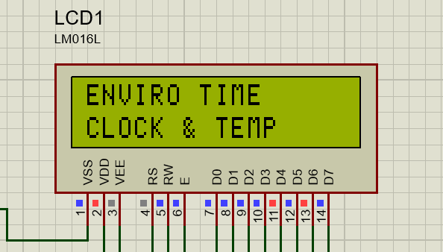
  - Real-Time Clock and Temperature Display
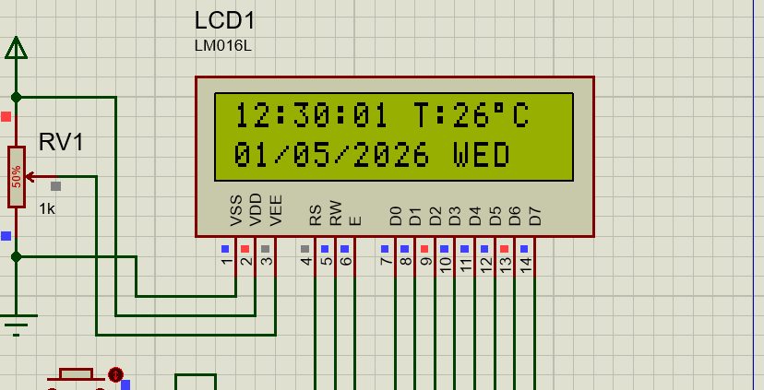
  - Password Authentication Screen Invalid Password Indication
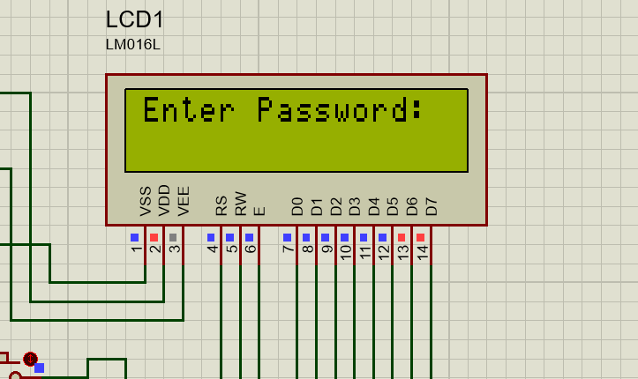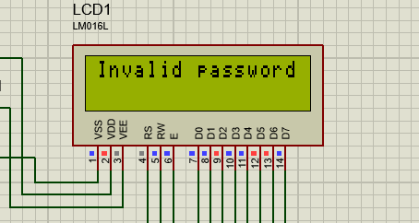

Password correct screen System locked
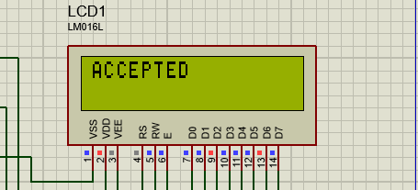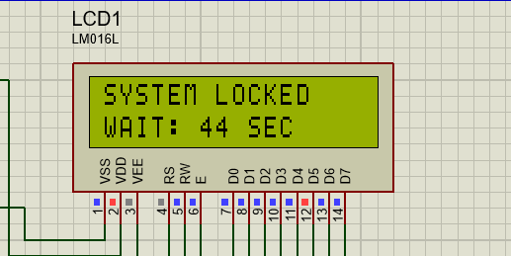
  - Main Edit Menu
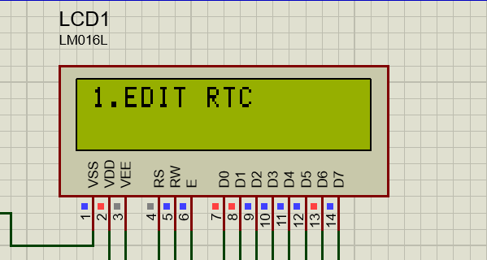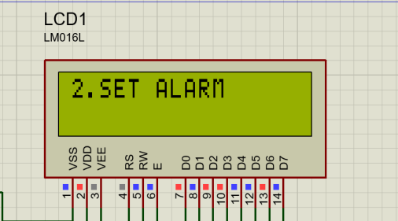
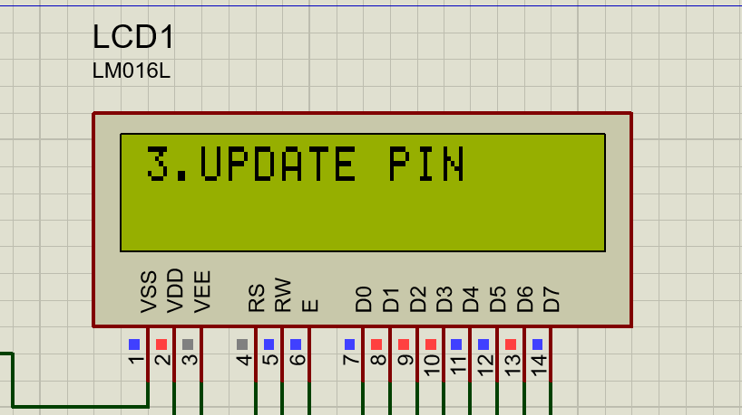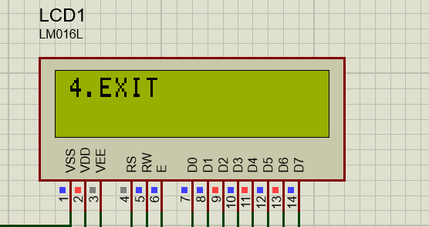
  - EDIT RTC
    - HOUR
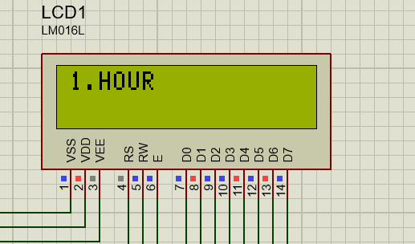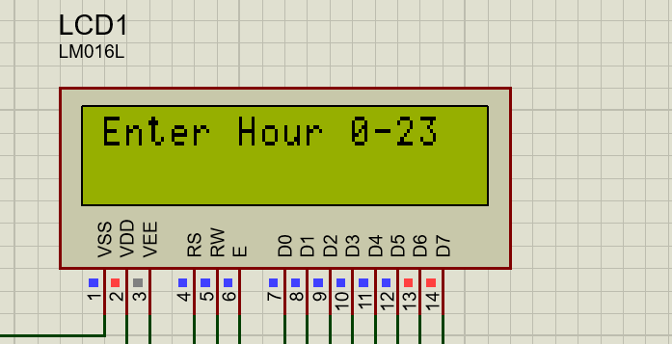
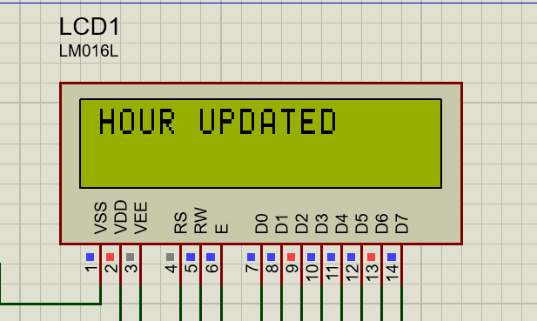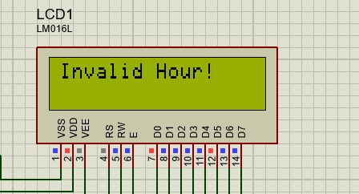
    - MINUTE
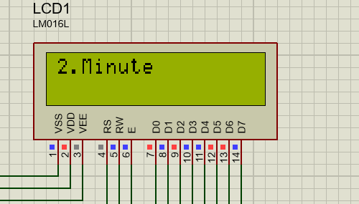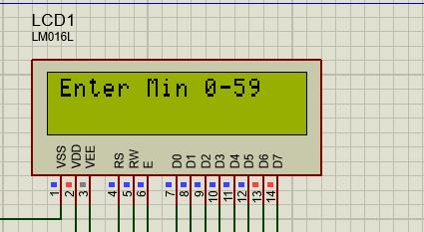
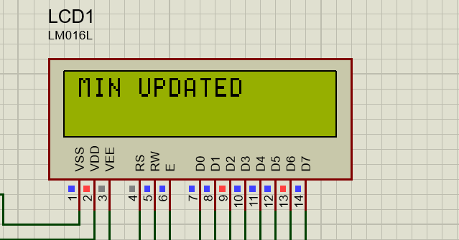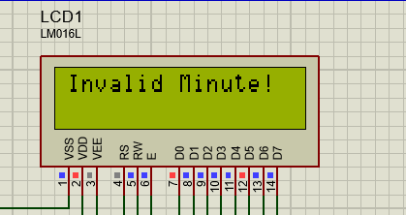
    - SECOND
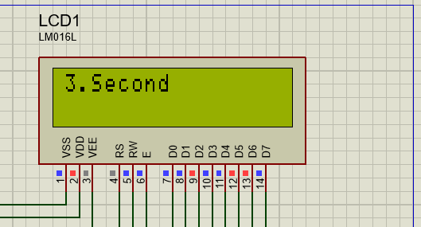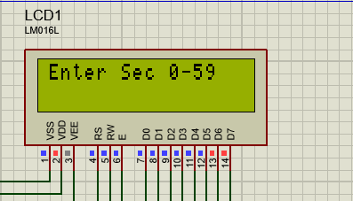
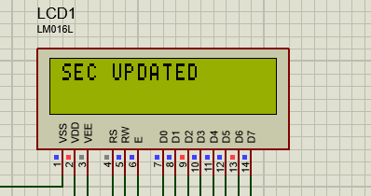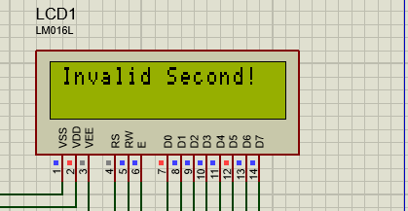
    - DAY
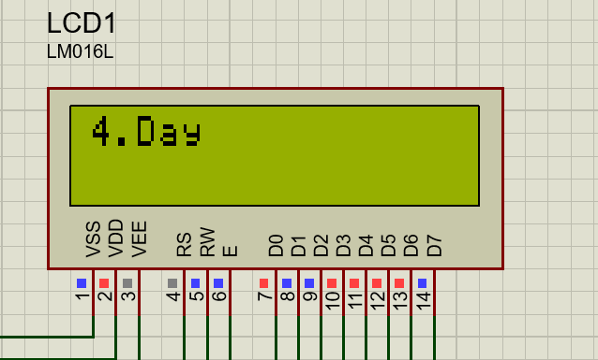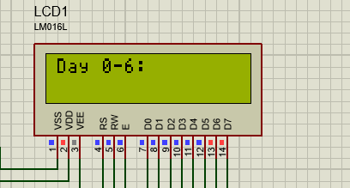
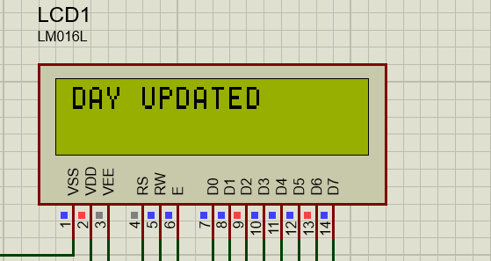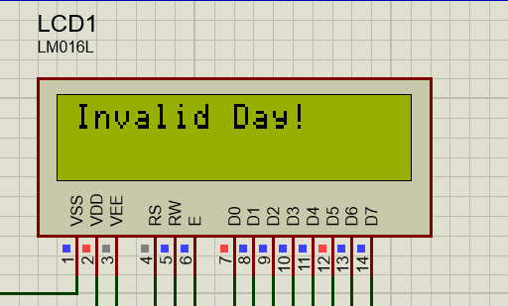
    - DATE
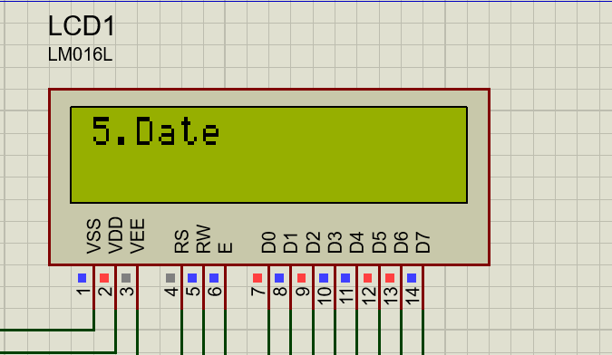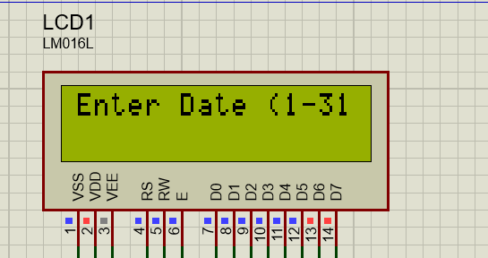
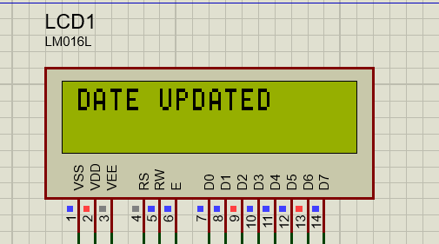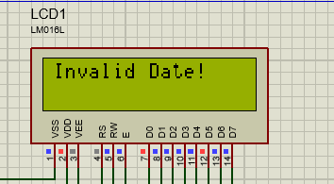
    - MONTH
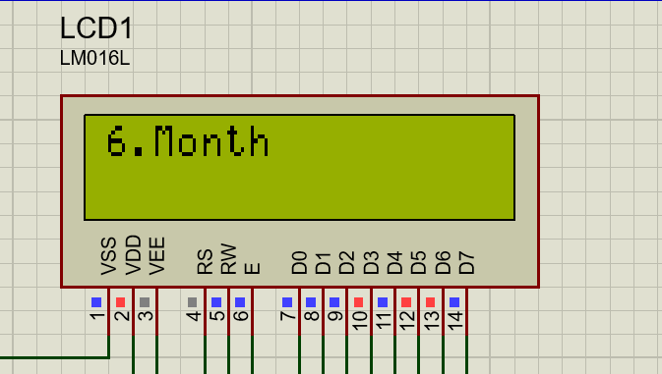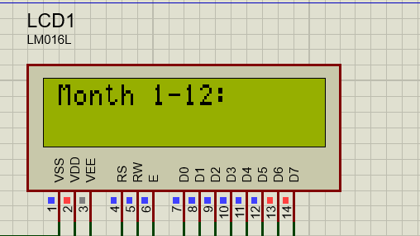
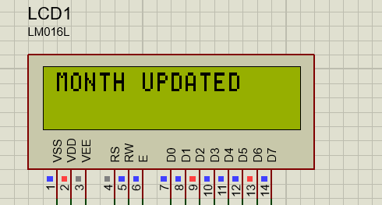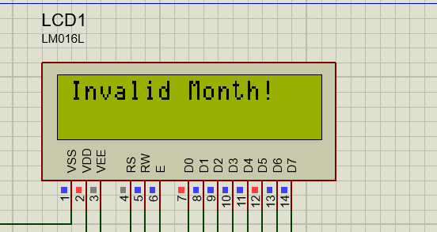

    - YEAR
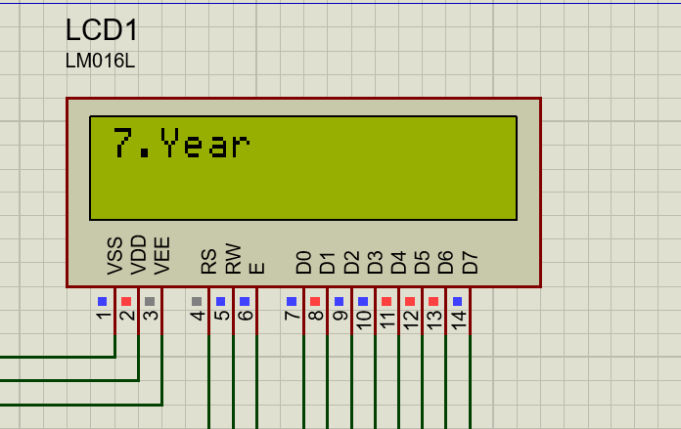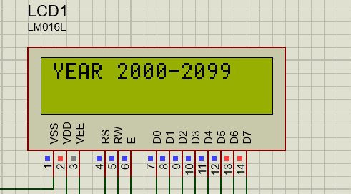
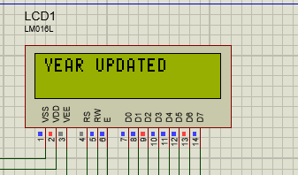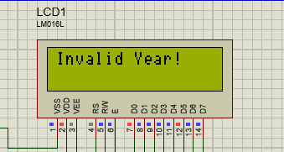
    - EXIT
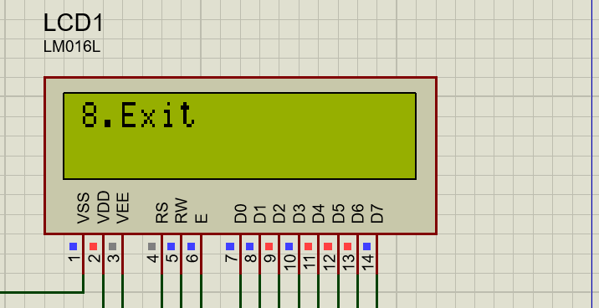
    - RTC UPDATED
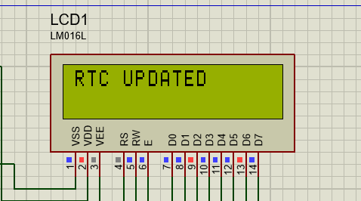
  - Alarm setting
    - Set hour screen Set min screen
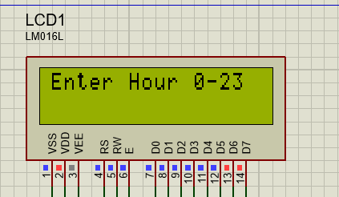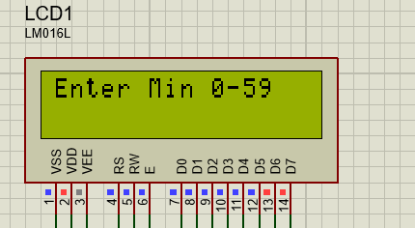

    - Invalid hour Invalid minute
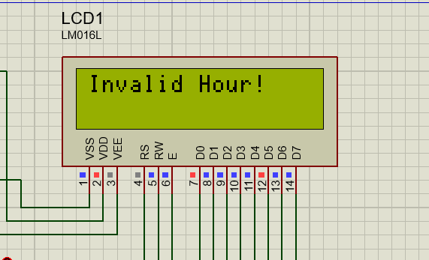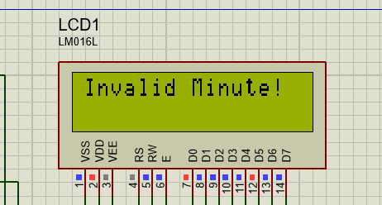
    - Alarm saved
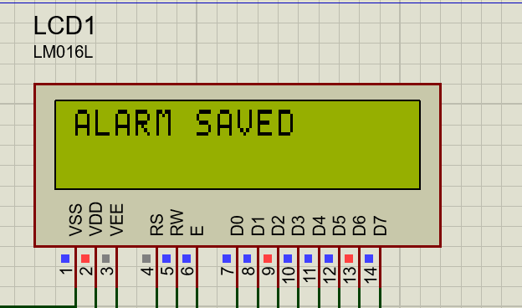
  - Alarm Indication
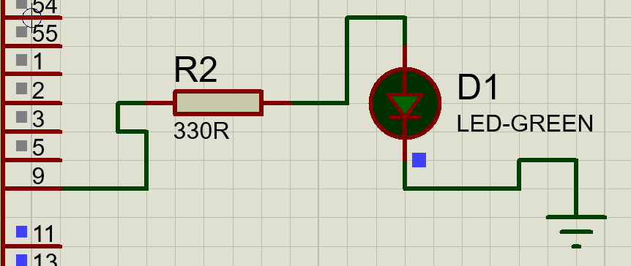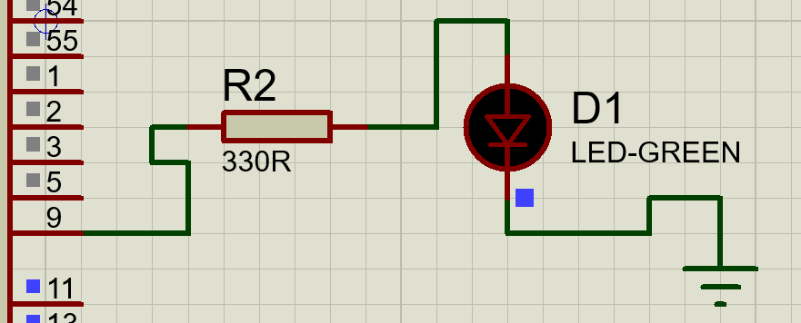
BUZZER ON Buzzer OFF
  - UPDATE PIN
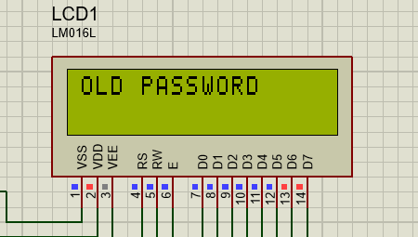
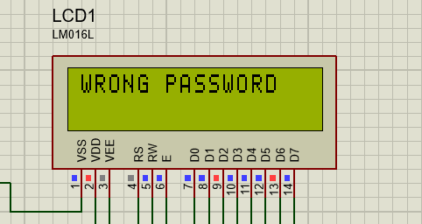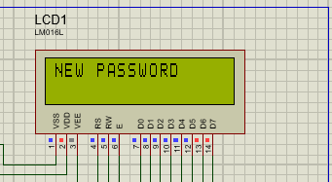

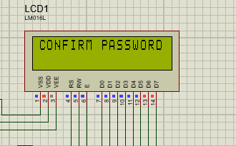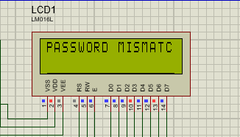
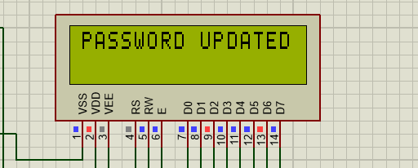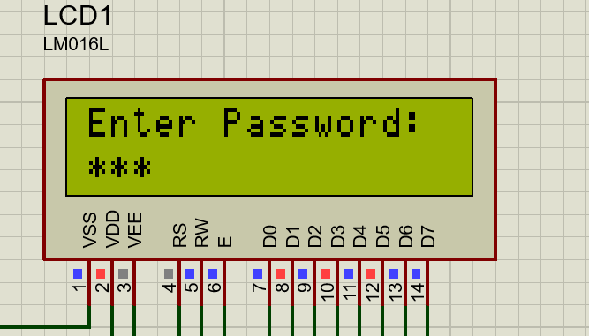

- Applications:
The applications of this project are:
  - Used in homes for displaying time and room temperature.
  - Used in offices for real-time clock and temperature monitoring.
  - Used in laboratories where temperature monitoring is important.
  - Used in hospitals to monitor room temperature and time.
  - Used in industrial areas for basic environmental monitoring.
  - Used in schools and colleges as a digital clock with alarm and security feature.
  - Can be used as a basic model for smart home automation systems.

- Advantages :
The advantages of this project are:
  - Provides accurate real-time clock display using the built-in RTC of the LPC2148.
  - Continuously monitors ambient temperature using the LM35 sensor.
  - Provides password-based security for editing system parameters.
  - Supports user-friendly interaction through 4×4 matrix keypad and LCD display.
  - Provides alarm indication through LED for easy monitoring.
  - Compact and low-power embedded system.
  - Easy to implement, test, and expand for real-time applications.
  - Suitable for both simulation and real hardware implementation.
  - Improves reliability and security in monitoring applications.

- Conclusion :
The EnviroTime project was successfully designed and implemented using the LPC2148 microcontroller. The system successfully displayed real-time clock information and ambient temperature on the 16×2 LCD using the LM35. Password-based secure access, time and alarm editing, and alarm indication through LED were implemented successfully. The project achieved all the intended objectives and demonstrated the effective integration of embedded hardware and software for real-time monitoring and security applications.
- Future Scope:
  - Wireless communication modules such as ESP8266 or Bluetooth can be integrated for remote monitoring and wireless data transmission.
  - Real-time clock and temperature data can be stored in non-volatile memory devices such as EEPROM or Flash Memory for data logging and analysis.
  - Additional sensors such as humidity sensors, gas sensors, or motion sensors can be interfaced to enhance environmental monitoring capabilities.
  - The system can be integrated with smart home and industrial automation platforms for intelligent monitoring applications.
  - Implementation of temperature history recording for monitoring and analyzing environmental changes over time.
  - Cloud-based monitoring and notification features can be implemented for IoT applications.
- References:
- LPC2148 User Manual, NXP Semiconductors.
- LM35 Temperature Sensor Datasheet, Texas Instruments.
- Keil µVision 4 Software Documentation.
- Proteus Design Suite User Manual.
- Embedded C Programming reference materials and laboratory manuals.
- ARM7 Microcontroller interfacing and embedded systems textbooks.

